HTML URLs and Resources

📘 Definition
# Source: AI Source: Provided by: [Data Path: Persons Table -> ID Column: 1, Name_En Column: Motasem Essam] -> From: [ChatGPT] on [5/6/2026]
In HTML, URLs (Uniform Resource Locators) are used to locate and access resources like:
- 🌐 Web pages
- 🖼️ Images
- 🎬 Videos
- 🎵 Audio files
- 📄 Documents (PDF, etc.)
- 🎨 CSS files
- ⚡ JavaScript files
A resource is anything a webpage needs to load or display.

🔗 Types of URLs in HTML
# Source: AI Source: Provided by: [Data Path: Persons Table -> ID Column: 1, Name_En Column: Motasem Essam] -> From: [ChatGPT] on [5/6/2026]
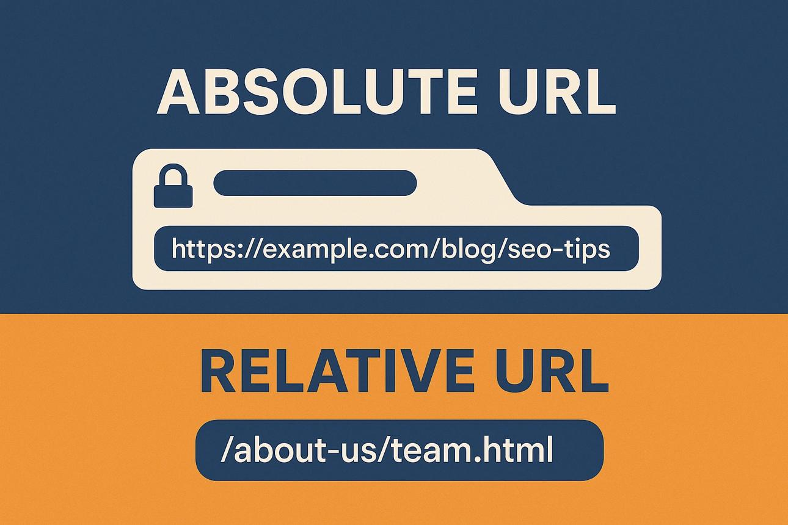
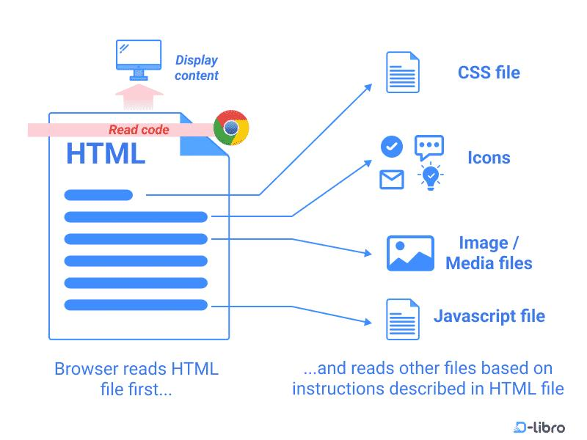
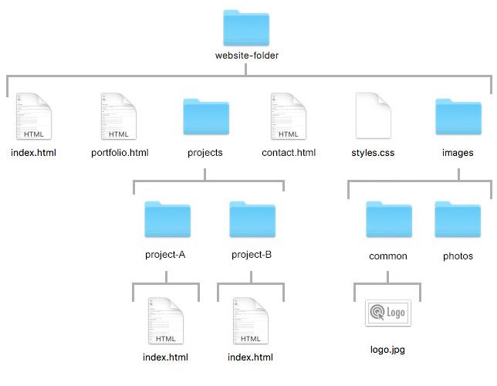

🌍 1. Absolute URL
# Source: AI Source: Provided by: [Data Path: Persons Table -> ID Column: 1, Name_En Column: Motasem Essam] -> From: [ChatGPT] on [5/6/2026]
📖 Description:
A full web address that includes:
- Protocol (https://) -> tells the browser how to connect securely to the website
- Domain name (www.google.com) -> the address/name of the website
- Path (/search?q=html) -> the specific page or location inside the website
💻 Example:
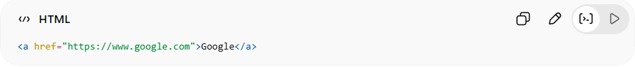
<a href="https://www.google.com">Google</a>
👉 Works from anywhere

📁 2. Relative URL
# Source: AI Source: Provided by: [Data Path: Persons Table -> ID Column: 1, Name_En Column: Motasem Essam] -> From: [ChatGPT] on [5/6/2026]
📖 Description:
A path based on the current file location.
💻 Example:
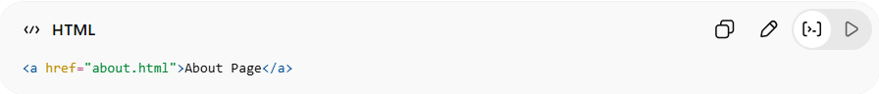
<a href="about.html">About Page</a>
👉 Looks inside same website folder

🧠 3. Root-relative URL
# Source: AI Source: Provided by: [Data Path: Persons Table -> ID Column: 1, Name_En Column: Motasem Essam] -> From: [ChatGPT] on [5/6/2026]
📖 Description:
Starts from the website root /.
💻 Example:
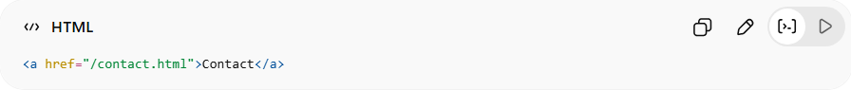
<a href="/contact.html">Contact</a>

🧩 Common HTML Resources

🖼️ 1. Images
# Source: AI Source: Provided by: [Data Path: Persons Table -> ID Column: 1, Name_En Column: Motasem Essam] -> From: [ChatGPT] on [5/6/2026]
📖 Description:
Used to display pictures.
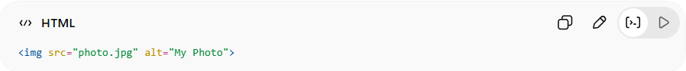
<img src="photo.jpg" alt="My Photo">

🎨 2. CSS Files
# Source: AI Source: Provided by: [Data Path: Persons Table -> ID Column: 1, Name_En Column: Motasem Essam] -> From: [ChatGPT] on [5/6/2026]
📖 Description:
Used for styling.
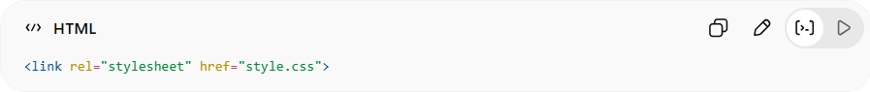
<link rel="stylesheet" href="style.css">

⚡ 3. JavaScript Files
# Source: AI Source: Provided by: [Data Path: Persons Table -> ID Column: 1, Name_En Column: Motasem Essam] -> From: [ChatGPT] on [5/6/2026]
📖 Description:
Used for interactivity.
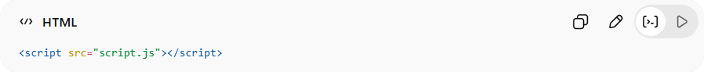
<script src="script.js"></script>

🎬 4. Videos
# Source: AI Source: Provided by: [Data Path: Persons Table -> ID Column: 1, Name_En Column: Motasem Essam] -> From: [ChatGPT] on [5/6/2026]
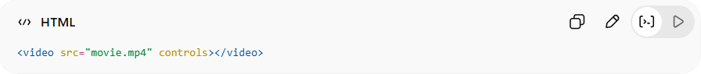
<video src="movie.mp4" controls></video>

🎵 5. Audio
# Source: AI Source: Provided by: [Data Path: Persons Table -> ID Column: 1, Name_En Column: Motasem Essam] -> From: [ChatGPT] on [5/6/2026]
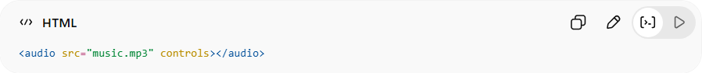
<audio src="music.mp3" controls></audio>

📄 6. Documents (PDF)
# Source: AI Source: Provided by: [Data Path: Persons Table -> ID Column: 1, Name_En Column: Motasem Essam] -> From: [ChatGPT] on [5/6/2026]
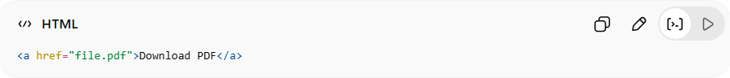
<a href="file.pdf">Download PDF</a>

⚙️ How browsers load resources
# Source: AI Source: Provided by: [Data Path: Persons Table -> ID Column: 1, Name_En Column: Motasem Essam] -> From: [ChatGPT] on [5/6/2026]
- Browser reads HTML
- Finds URLs (src, href)
- Requests resources from server
- Displays them in the page

⚠️ Important Concepts

🧭 Path types matter
# Source: AI Source: Provided by: [Data Path: Persons Table -> ID Column: 1, Name_En Column: Motasem Essam] -> From: [ChatGPT] on [5/6/2026]
- ✔ Correct path → resource loads
- ❌ Wrong path → broken image/link

🚫 Broken resource example
# Source: AI Source: Provided by: [Data Path: Persons Table -> ID Column: 1, Name_En Column: Motasem Essam] -> From: [ChatGPT] on [5/6/2026]
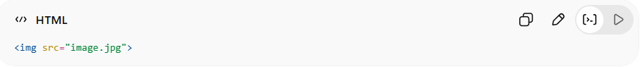
<img src="image.jpg">
👉 If file doesn’t exist → broken image icon

🚀 In short:
# Source: AI Source: Provided by: [Data Path: Persons Table -> ID Column: 1, Name_En Column: Motasem Essam] -> From: [ChatGPT] on [5/6/2026]
HTML URLs and Resources = the links and files (images, CSS, JS, media) that a webpage uses to load and display content.

